Network latency check

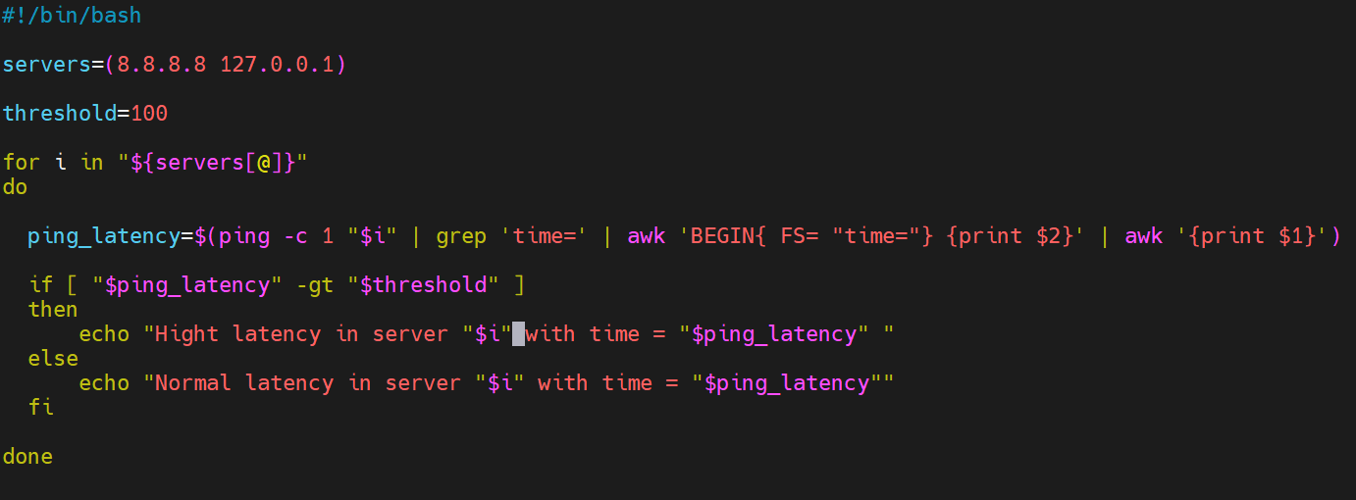
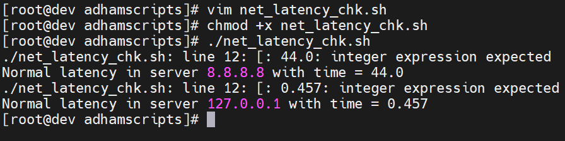

Explain:
$1
$2
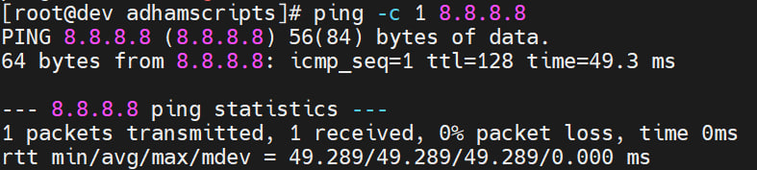
$2
$1

